# **There Is No Instruction Manual**

**Zoe's avatar**

[Zoe](https://substack.com/@zoeffc)

Oct 11, 2024

Share

Hey!

I have decided to embrace my Eyore tendencies and bum everyone out this week. I know that’s why you are all here, despair and despondency.

I am writing a note that I need to read, but I am betting that I am not the only one. It centers around the following ideas:

1. There is no instruction manual for your life.
2. A lot of people are going to make you think that there is an instruction manual.
3. Shit can go awry and it can still work out.

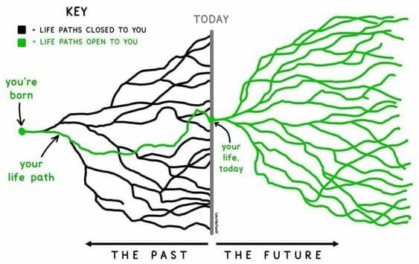

*Artist unknown*

First some housekeeping:

📫 If a friend forwarded you this newsletter (then you have some really cool friends), and you may want to consider joining us here for regular updates.

[Subscribe](https://femme-futures.beehiiv.com/subscribe)

🧲 Got some thoughts you want to share? Join us on Discord to chat all things newsletter and corporate life.

[Discord](https://discord.gg/N84WxemQ?utm_source=femme-futures.beehiiv.com&utm_medium=referral&utm_campaign=there-is-no-instruction-manual)

You can find all archived newsletters at the online site, if you ever want to go back or if you just feel like perusing.

[Check out the website](https://femme-futures.beehiiv.com/)

**First, there is no instruction manual for your life.** Oh little perfectionist, I know, I want one too. I want 100 clear steps to live my best possible life. I want to know that I am guaranteed Z if I do Y and X.

Unfortunately, your path is not predetermined. Think about it. There are a million ways that your life could branch at each decision you make, or the decisions made by those who you love. Hell, you could make no decision at all and still wake up one morning with cancer. Those 100 clear steps probably don’t include cancer.

What I am trying to say is, embrace the infinite number of permutations for your life, and know that you have some control and when you do not have control over the circumstances, you have control over your reaction. You are going to make a plan, be that for the day ahead, the next five years, or until you die. It will be a glorious plan, and I am by no means telling you not to make a plan. But know that as much as you want it to happen, that plan may not pan out.

Alternatively, if making the plan is the hard part, that’s ok. Drifting is an essential part of coming of age. When you leave college, your brain actually cannot comprehend all of the choices that you will make throughout your life. No one can plan for each of those choices. It is impossible. If you are drifting, take that and run with it. Make choices that feel aligned with what is interesting and exciting to you and see where it takes you.

The hardest thing that I am learning in my twenties is that my life is a lot longer than I ever gave it credit for and I am absolutely incapable of even imagining more than three possible futures. I can however, learn to trust myself and go from there.

**Second, a lot of people are going to make you think that there is an instruction manual.** There isn’t. When Uncle Rick starts telling you that you need to be investing in crypto currency, or Auntie Helen keeps telling you that the only way to get a boyfriend is to go into marketing, think of it as an advice column. This person has very little contextual information, and you weren’t even the question writer. This advice might not be for you at all.

(That applies to all of the shit that comes out of my mouth, too.)

Likewise, when you look around yourself, you will see people who seem to have been handed an instruction manual because they are succeeding at life. I wish I could tell you that they are dealing with their own shit (they probably are, but that doesn’t make me feel better, so I doubt it will serve you). Their paths are just totally and completely different from our own. They fell into a gravitational pull that is shooting them like a rocket in a very specific direction. When you catch yourself comparing your life to theirs, it might be helpful to take a second to be grateful for the things that you have in your life that they likely don’t have in theirs. (Like hobbies.)

*You* are one of the people who is going to make you think that there is an instruction manual. I beg of you not to look back at your life and convince yourself that everything went as planned. I can guarantee that it did not. You ran into walls and stumbled and are probably walking around with a fat black eye. *But,* if you are looking at your life now and thinking that you probably did something right to end up here, take that knowledge and let it prove that you can trust yourself, even through challenge.

**And finally, shit can go awry and it can still work out.** Ok, you probably get the message at this point. Shit happens, whether that shit was caused by you, someone you love, or the universe. You can catastrophically fuck up the plan and then look up from your life a year later and think, “Oh? That’s the worst that came of that?” or “While I will never ever in my life make that mistake again, I made the most of it, and look at me now.” I think that it is clear that I am writing to my niche today: overachievers and perfectionists. That is why I am going to say this. Trust me, you could have fucked up worse.

Life throws bombshells at you that will totally mess everything up. When I was a sophomore in college, the pandemic hit and my plans of spending two semesters studying in Europe before going on to get a Masters in International Relations before going to work for the UN were totally thrown to shit. (I admit, there were more than a few ways that this could have not panned out. Stick with me.) So, in March of 2020, I flew back to my parents’ apartment in Singapore and, so as to avoid taking online classes with a 12 hour time difference, enrolled in a university there. That counted as my study abroad. Goodbye dreams of Geneva, hello, Mom and Dad’s guest room.

And you know what? I think I may have regretted getting a degree in International Relations. I think that going that bureaucratic that quickly would have had a real impact on my sense of self and my creativity. Instead I got the chance to work for a climate nonprofit and see how a start-up works. The small nature of my early career organizations allowed me to get a real sense of what teamwork and leadership looks like. So yes, 19-year-old Zoe would be quite surprised by this turn of events, but look at me now.

To all of you on your confusing messy life paths. Good luck. Shit’s hard.

Zoe

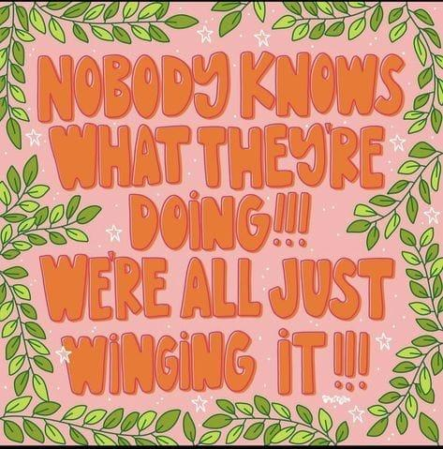

**Femme Futures Cooperative Founding Principles**

💚 **Mission**: The mission of Femme Futures is to create a community space for young professionals who identify as over-achievers and activists to generate collective success by providing resources and platforms to thrive in challenging workplace environments.

💙 **Vision**: To contribute to a world where driven individuals are equipped with the tools, guidance, and connections to overcome systemic barriers, fully utilize their talents, and enact positive change in their organizations and communities.